**Assignment 14/03/2022**

**Part 1**​ **(Shell scripting)**

**Note1:**​ For the following assignments, accept only integer values from user. If user enters value other than integer display error message and terminate the program.

**Note2:**​ If you want to perform the following arithmetic operations with Floating point values make use of **Basic calculator** ​in your script.

(**Hint:**​ use **bc**​ command for Basic calculator)

1. Write a shell script to Print prime numbers from 1 to **n**​. Read the value of **n** from user.

2. Write a script to check given number is even or odd.

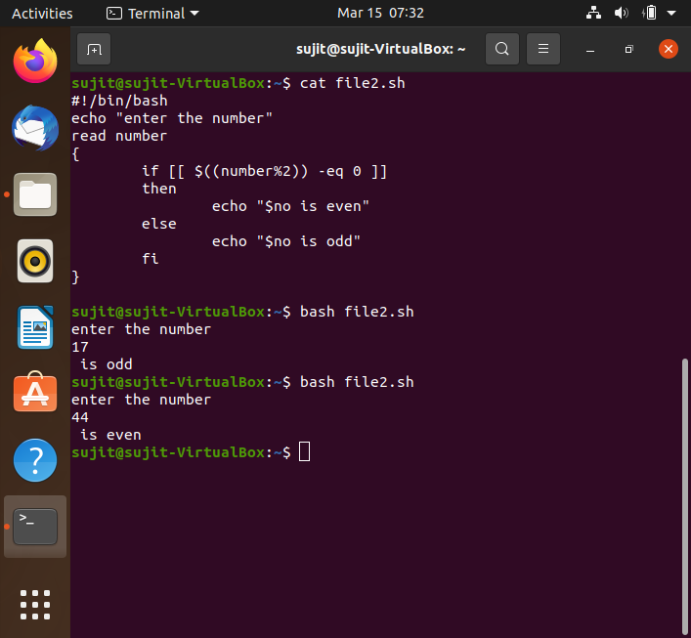

3. Write a shell script to convert a decimal number to binary number. 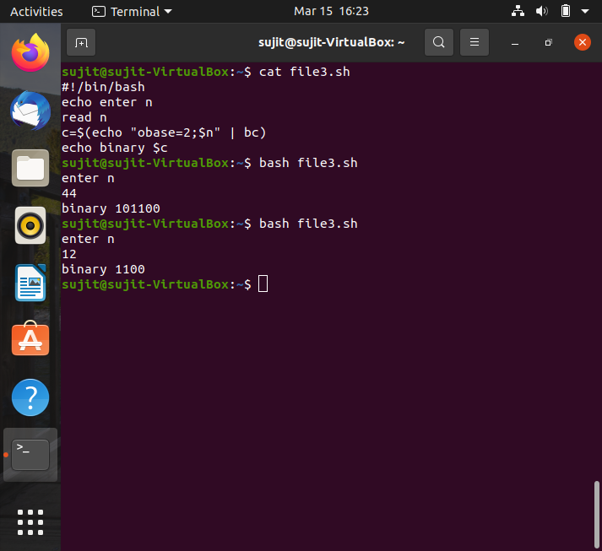

4. Write a script to **swap**​ 2 numbers using intermediate variable.

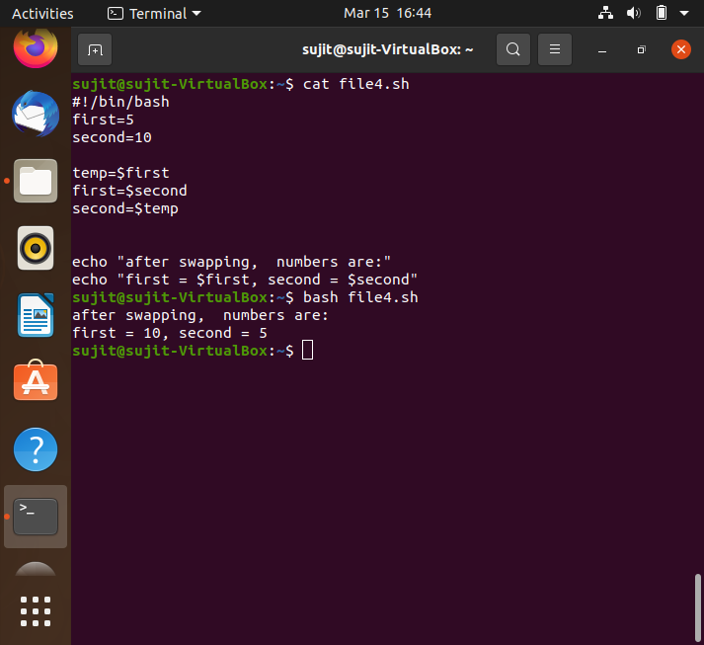

5. Write a script to **swap**​ 2 numbers without using intermediate variable.

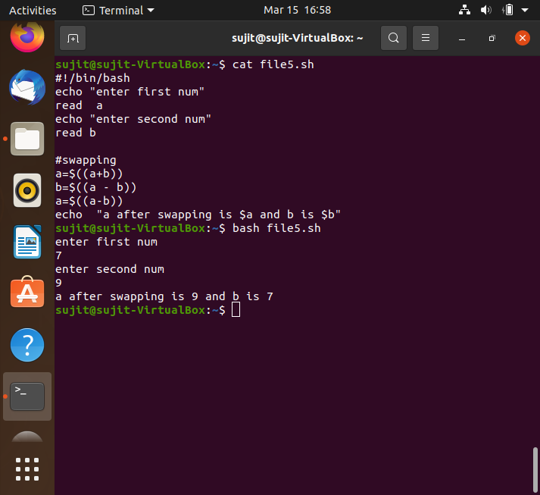

6. Write a script to reverse a number using while loop.

Example: input : 12 output: 21,, input : 213 output: 312 ,,input : 125634 output:436521

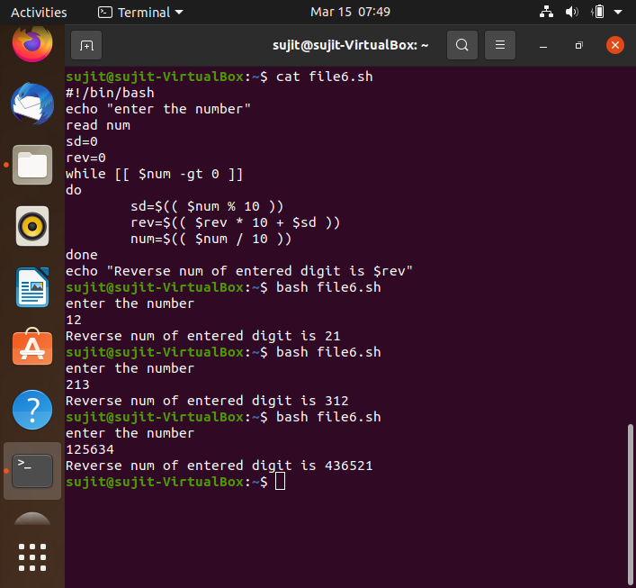

7. print multiplication table of integer using while loop.

Example:

2 x 1 = 2

2 x 2 = 4

……….

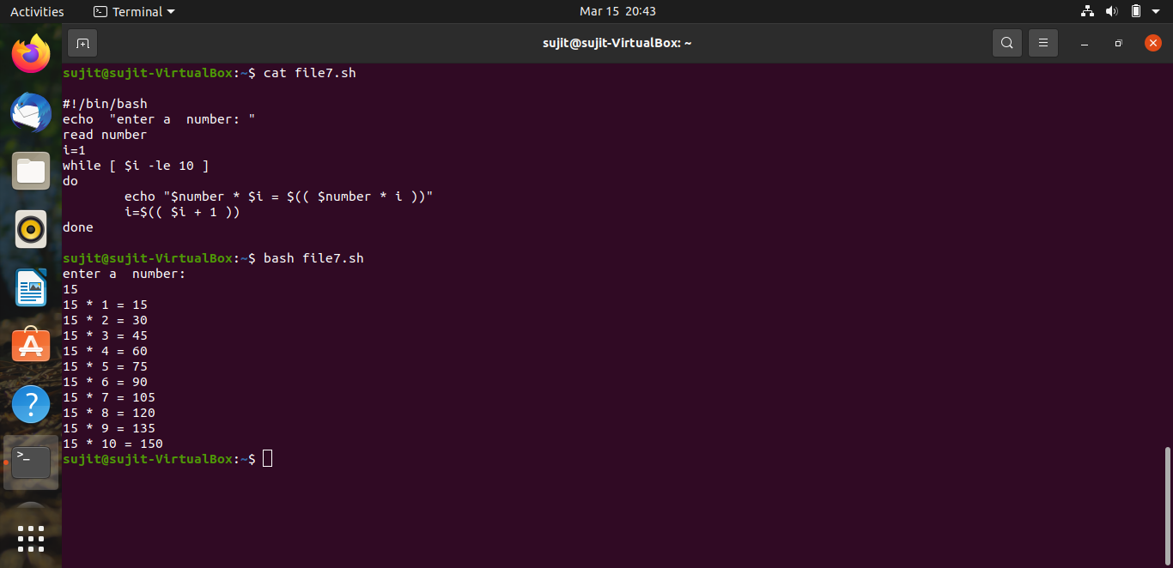

8. Get year as an input from user and find whether year is leap year or not.

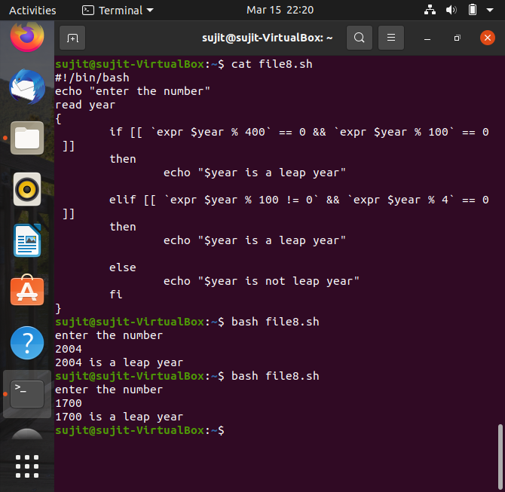

9. Write a script to read the number of rows to be displayed in the pattern and print following pattern using for loop:

1

2 3

4 5 6

….....

10. Write a script using **case**​ condition to do the following

- Display “Press any key of keyboard and then press enter key”

- If the given input is number display “The input is digit.” message - If the given input is lowercase letter then display “The input is lowercase Letter.” message

- If the given input is uppercase letter then display “The input is Uppercase letter.” message

11.Write a for loop to display the outputs of **Date,pwd, df** ​commands. **df** command displays system disk usage details.

(**Hint:**​ give these commands as input to for loop)

12.Write a script to take filename as argument and display the file exists or not **Note:**​ If the file exists in current working directory just give filename as argument, If not give absolute path of that file as argument.

13.Write a script to take directory name as argument and display the directory exists or not.

**Note:**​ If the directory exists in current working directory just give filename as argument, If not give absolute path of that file as argument.

14.Read a file and display the contents of the file line by line using for loop and pass the file as command line argument to the script.

15.Read a file and display the contents of the file line by line using while loop and pass the file as command line argument to the script.

16.Write a shell script to read array elements as command line arguments assign the arguments to array and do the following

- Display the length of the array.

- Display the all elements and their index values.

Example :

let the array elements are as follows

arr[0]=”zero”, arr[1]=”one”, arr[2]=”two”,

output should be :

length of the array : 3

index 0 element is “zero”

index 1 element is “one”

index 2 element is “two”

17. Write a program to read array of 10 integers from user and find the smallest number in the array and print it.

18. Write a single shell script to do the following

- read two numbers as input from terminal.

- write Add,Sub and Mul functions to perform addition,subtraction and multiplication between two integers.

- Display the results(**Note:** ​To display float results using basic calculator.)